# ISEE Dashboard installation guide

This is a quick guide to be able to use ISEE dashboard on your computer. It has been tested among colleagues, who are familiar with Pyhton coding and open source softwares and no major issues were reported. Now, the intent of this document is to make ISEE dashboard accessible to a broader audience. Hence, feel free to communicate any problems or to formulate any recommendations that would clarify the content of the present document (antoine.maranda@ec.gc.ca).

** in the following pages, anything that is between {curly brackets} refers to a variable. For instance if you chose to put the ISEE dashboard data in this folder : F:\GLAM_DASHBOARD\ISEE_Dashboard. When it is written *create the following folder: {your local folder}\data* it means that you should create F:\GLAM_DASHBOARD\ISEE_Dashboard\data folder.

## Installation main steps

The following steps will be described in more details throughout the document.

1. Download and unzip ISEE dashboard files
2. Download, Install and setup Anaconda on your computer
3. Create conda environment with dashboard requirements
4. Adjust paths in the code to point on your local repositories
5. Run the Dashboard with Streamlit

## Download and unzip ISEE dashboard files

All necessary files can be found on the GLAM sharepoint following this link: [ISEE_Dash_portable](https://ijccmi.sharepoint.com/:f:/s/GLAM/EhRoYbNdDexDoffL5hnx4d4BNTSg0ZDqjToIJOR1HezUwg?e=uVu31B)

Once downloaded you can unzip each of the folders. Place the unzipped folders at a specific location that will be now referred as {your local folder}

## Download, Install and setup Anaconda on your computer

If you already have Anaconda on your machine you can skip to step 3.

If not, please follow these steps (probably the most complicated part of the process don’t be discouraged)

### 2.1: Download Anaconda

* + Go to the Anaconda website ([Download Now | Anaconda](https://www.anaconda.com/download/success)) and download the installer for Windows.
  + Choose the version for Windows.
  + Once downloaded, open the installer to begin the installation.

### 2.2: Install Anaconda

* + **Launch the installer** and follow the prompts:
    - Click **Next** on the welcome screen.
    - Agree to the license agreement.
    - Choose the installation type (All Users or Just Me). Selecting **Just Me** is usually fine for personal use.
    - **Select the installation location**. You can leave it as the default location or choose a custom one.
  + **Add Anaconda to your PATH environment variable**:
    - During installation, select the checkbox **"Add Anaconda to my PATH environment variable"**. This option will make it possible to run Conda commands directly from the Command Prompt.
    - If you don’t see this option, you may need to modify PATH manually after installation (covered in Step 2.3).
  + Click **Install** to complete the process.
  + When the installation finishes, click **Next**, and then **Finish**.

### 2.3: Verify Installation and Set PATH (if needed)

* + **Open Command Prompt**:
    - Press **Win + R**, type cmd, and hit **Enter**.
  + **Check Conda Installation**:
    - Write the following command to verify that Conda is installed and press enter:

conda --version

* + - If it returns a version number (e.g., conda 4.10.3), Conda is successfully installed and ready to use.
  + **If Conda Command Is Not Recognized**:
  + **Set PATH Manually**:
    - **Type “env” on the search bar on the bottom left of your screen**
    - 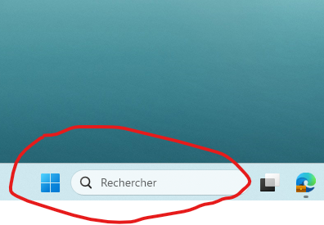
    - **Select** "Edit environment variables for your account" from the results.
    - Under **Users variables**, find the **Path** variable, select it, and click **Edit**.
    - Click **New** and add the following path:

{Where you installed Anaconda}\Anaconda3

* + - Also add:

{Where you installed Anaconda}\\Scripts

* + - Click **OK** to save and close all dialog boxes.
  + Close and reopen Command Prompt, then verify Conda with conda --version again.

## 3. Create conda environment with dashboard requirements

* + **Open Command Prompt**:
    - Press **Win + R**, type cmd, and hit **Enter**.
  + Write: conda env create -f "{your local folder}\ISEE_Dashboard\streamlit.yml" and press enter
  + Once the environment is installed, activate it by writing: conda activate streamlit and press enter

Your command prompt window should look like this :

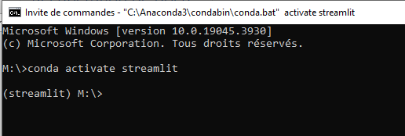

## Adjust paths in the code to point on your local repositories

* + Open the following file with any IDE (or Notepad if you don’t have any) : "{your local folder}\ISEE_Dashboard\DASHBOARDS\ISEE\CFG_ISEE_DASH.py"
  + Edit the variables “shapefile_folder” and “post_process_folder” (line 13 and 14) to point towards your local folders:
    - Shapefile_folder=fr” {your local folder}\shapefiles”
    - post_process_folder=fr” {your local folder}”
  + Save your edits and close the file

## Run the Dashboard with Streamlit

* + In the command prompt that was opened in step 3, write the following:

streamlit run "{your local folder} \ISEE_Dashboard\DASHBOARDS\ISEE\ISEE_DASH_0_1.py" and press enter

The Dashboard should automatically open in a web browser:

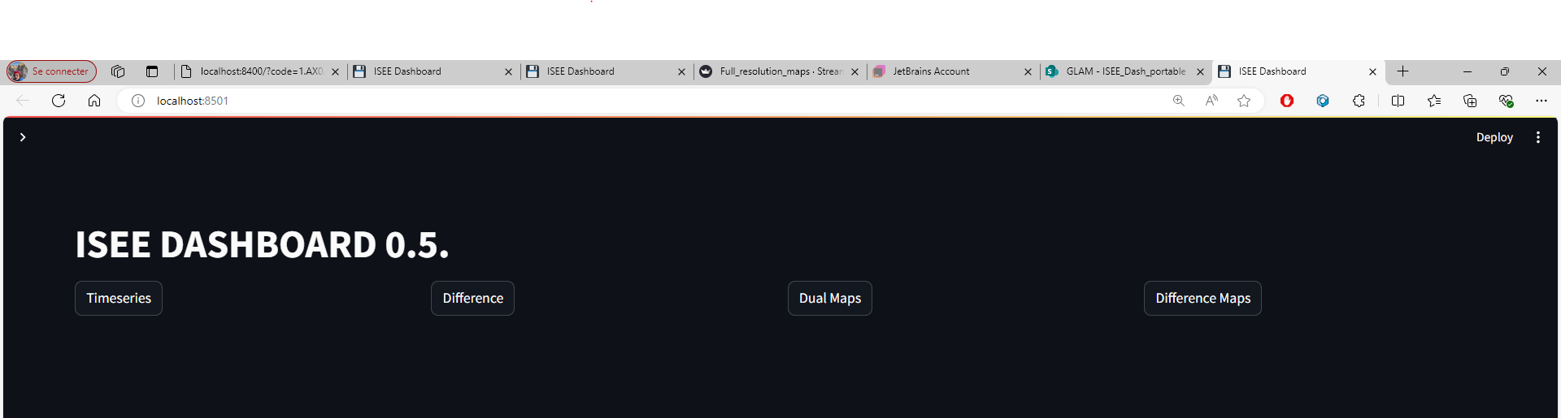

You then click on one of the four tabs to display different type of plots, which you can adjust with the widgets on the left:

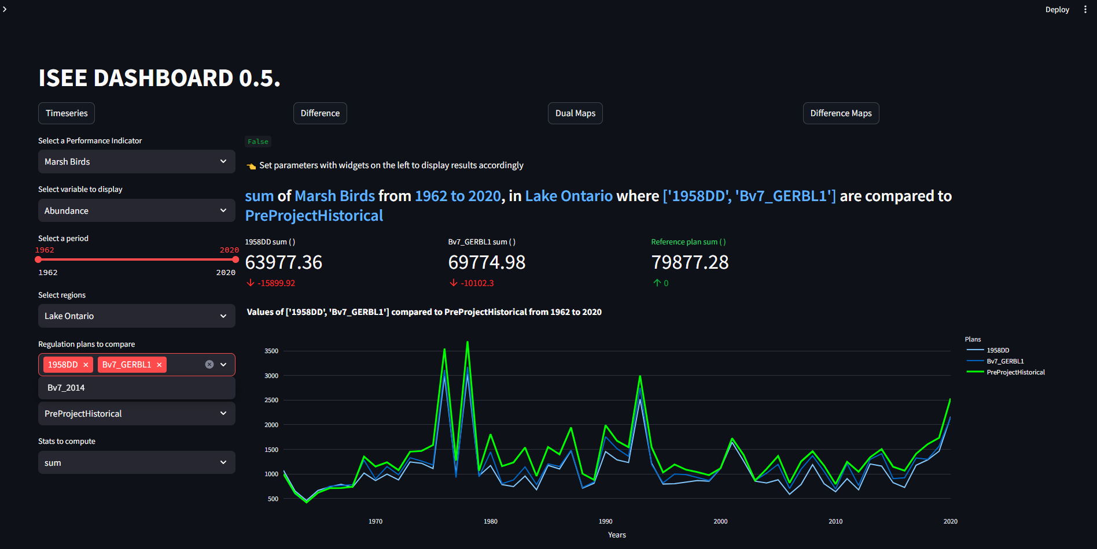

If you need to stop the dashboard and rerun:

In the command prompt you need to press CTRL+C

Afterwards, It should look like this:

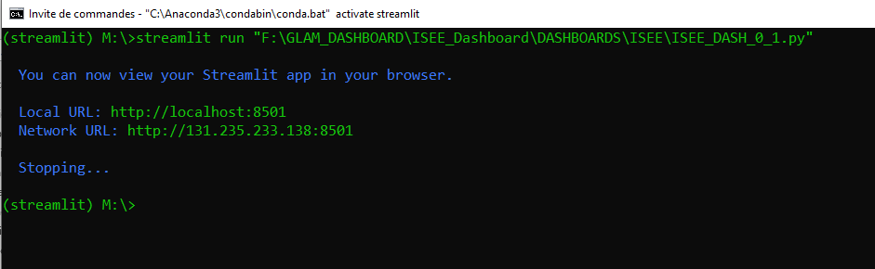

Then you can simply rerun the dashboard by typing :

streamlit run "{your local folder} \ISEE_Dashboard\DASHBOARDS\ISEE\ISEE_DASH_0_1.py"

!!!IMPORTANT!!!

If you close your command prompt window, for any subsequent runs, **make sure to activate your streamlit Conda environment (by typing “conda activate streamlit”) before trying to launch the dashboard**, it is not the case by default when you open a command prompt.

It tells you in parenthesis which conda environment is activated.

